Add ‘tips’ – info buttons for guidance

**Initial Editor**

Cuts off field title (even with expansion)

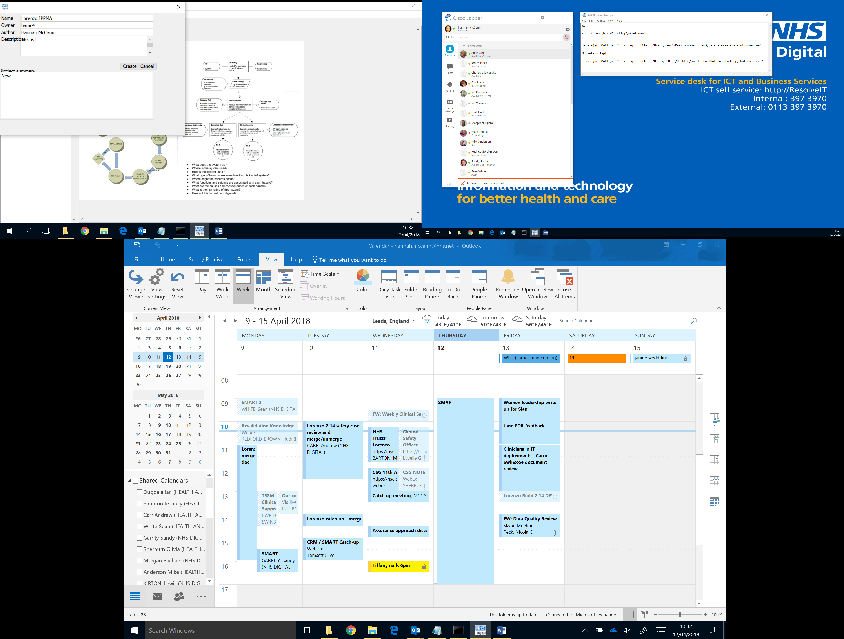



Double clicking the project name does not relaunch the editor (does on existing projects)

**System**

Agree initial system could be defaulted as top system.

Is ‘build’ more relevant than version?

**Care Setting**

Clear data after save

**Role**

Clear data after save

**Care Process**

Wrap to boxes

Resize Process steps box in editor – Make list wider and Description shorter

What is the discard button for? (does not appear to perform any function)

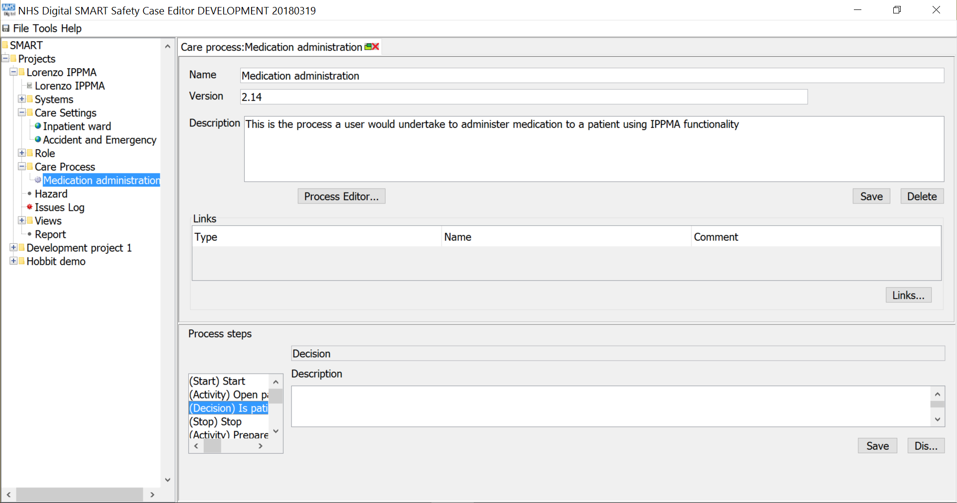

**Hazard Editor (Bowtie)**

Error message received – not clear where broken link is – once back checked all arrows attached and seemed to be, pressed save and didn’t get the error message. But after closing the tab, double clicking on the hazard would not call the editor (eventually did but bowtie not saved) Unable to edit or create new bowtie so have to redo the whole thing

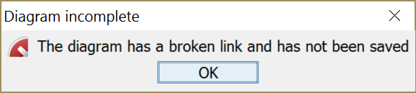

If I delete the hazard so I can recreate the bowtie, I get this message, but unsure how to purge. Also unable to delete the bowtie.



When close bowtie down and rename the hazard to start from scratch, get this messge

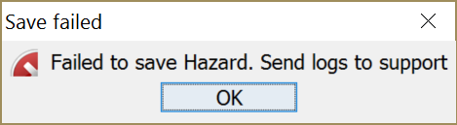

When creating a brand new hazard, identical to the one before (but different name) get this error around causes



However no (old) causes are showing in the tree.

Also the control details from bowtie haven’t saved.

